
DEPARTMENT OF COMPUTER SCIENCE AND ENGINEERING
Koneru Lakshmaiah Education Foundation (KLH), Bowrampet Campus, Hyderabad
Course: SOA Programming and Microservices (24SDCS03) — A.Y. 2026–2027
A RESEARCH PAPER ON
CivicPulse
Intelligent Event-Driven Urban Issue Management using Secure Microservices
Submitted by
S. No. | University ID | Name
1 | 2420030057 | P Dhanush
2 | 2420090147 | M Rohith
3 | 2420030776 | Ananya Sinha

Under the Guidance of
Dr. Srikanth Cherukuvada
Assistant Professor, Department of Computer Science and Engineering, KLH — Bowrampet Campus
Abstract
Rapid urbanization demands resilient, scalable solutions for municipal issue reporting and tracking. CivicPulse is an intelligent, event-driven urban issue management platform designed using a secure, distributed microservices architecture. Moving away from traditional monolithic and Service-Oriented Architecture (SOA) designs, CivicPulse leverages Apache Kafka for asynchronous event choreography and message streaming, ensuring real-time responsiveness across decoupled system components. Dynamic service discovery is established using Spring Cloud Eureka, while Spring Cloud Gateway handles centralized routing, load balancing, and Cross-Origin Resource Sharing (CORS) enforcement across all system endpoints.
To preserve service autonomy and high performance, the platform implements a database-per-service pattern powered by Spring Data JPA. Recognizing the complex security threats inherent in microservices networks, CivicPulse integrates robust authentication and authorization mechanisms using Spring Security with JSON Web Tokens (JWT), with all inter-service and client communications additionally safeguarded via TLS/SSL protocols. This layered defense guarantees data integrity, confidentiality, and resilience against common vulnerability vectors across the distributed topology.
System reliability and continuous quality assurance are sustained through a multi-tier testing strategy incorporating unit, integration, and contract tests using JUnit 5, AssertJ, @SpringBootTest, and @DataJpaTest. Deployment workflows are fully automated through CI/CD pipelines managed via GitHub Actions, and the development cycle adheres to Agile practices — using Jira for user story mapping, sprint planning, daily stand-ups, security task tracking, test case reviews, and sprint retrospectives — to deliver a production-ready civic issue management system that is scalable, secure, intelligent, and resilient.
Keywords: Microservices Architecture; Event-Driven Architecture; Apache Kafka; Spring Cloud Gateway; Spring Cloud Eureka; JWT Security; Database-per-Service; CI/CD; Smart City; Civic Issue Management.

1. Introduction
Urban local bodies across the world are experiencing an unprecedented surge in citizen-reported civic issues — potholes, garbage overflow, broken streetlights, water leakage, and similar infrastructural concerns. Traditional civic issue management systems are largely built as monolithic, centralized web portals that couple presentation, business logic, and data persistence into a single deployable unit. While simple to build initially, such systems suffer from single points of failure, poor horizontal scalability, and sluggish, manual incident-reporting workflows that cannot keep pace with high-volume, concurrent citizen reports.
CivicPulse is proposed as an intelligent, event-driven urban issue management platform that reimagines civic-tech infrastructure using a secure, distributed microservices architecture. Instead of scaling a single application vertically, CivicPulse decomposes the system into independently deployable services — authentication, issue reporting, notification, and geospatial analytics — that communicate through well-defined synchronous APIs at the edge and asynchronous event streams internally. This design allows each service to be developed, tested, deployed, and scaled independently, directly addressing the scalability and reliability limitations of legacy civic portals.
The platform is architected around three foundational pillars. First, event-driven communication using Apache Kafka enables asynchronous, non-blocking interaction between services, so that a citizen submitting an issue receives an immediate acknowledgment while classification, deduplication, notification, and geospatial plotting proceed independently in the background. Second, a security-first design embeds JSON Web Token (JWT) based authentication, BCrypt password hashing, and TLS/SSL encryption at the API gateway and across inter-service calls, ensuring that sensitive citizen and municipal data remains protected end-to-end. Third, a database-per-service pattern isolates each microservice's persistent state, eliminating shared-database bottlenecks and preventing a fault in one domain from cascading into another.
This paper documents the motivation, related work, design, and implementation strategy behind CivicPulse. It presents the problem statement and identified research gaps in existing civic-tech and emergency-response literature, describes the proposed secure microservices architecture and its event-driven data flow, discusses the testing and CI/CD strategy that underpins production readiness, and evaluates the novelty of the proposed system against baseline architectures currently in use.

2. Literature Survey
A structured review of contemporary civic-technology and cloud-native emergency-response literature was undertaken to ground the design of CivicPulse in established engineering practice. Table 1 summarizes three representative works spanning fault-tolerant cloud-native architecture, event-driven IoT/civic data pipelines, and AI-assisted civic issue reporting.
Table 1. Summary of Literature Survey
Authors | Title of the Paper | Methodology | Key Inferences | Limitations / Future Work
Gbenle et al. | A Conceptual Model for Scalable and Fault-Tolerant Cloud-Native Architectures for Emergency Response Systems | Event-Driven Architecture (EDA), microservices decomposition, containerization (Docker/Kubernetes), and stream processing. | Decoupling critical services prevents single points of failure and vastly improves system uptime and operational elasticity during traffic spikes. | High operational complexity; future work targets dynamic auto-scaling policies and automated failover recovery mechanisms.
AirQo Team (Sserujongi et al.) | Design and Evaluation of a Scalable Data Pipeline for AI-Driven Air Quality Monitoring | Microservices architecture, Apache Kafka event streaming, Apache Airflow orchestration, and ML-driven data calibration models. | Asynchronous, Kafka-driven message queues allow high-volume IoT and civic data pipelines to process real-time and batch workloads without bottlenecks. | Relies heavily on high-bandwidth network connectivity; future research focuses on edge computing for intermittent network dropouts.
Grenze Research Group | Smart Civic Issue Reporting System | Convolutional Neural Networks (CNN) for image recognition, GPS geo-tagging, and automated micro-routing algorithms. | AI-assisted incident categorization (e.g., automatically identifying potholes or garbage dumps) reduces human effort and speeds up municipal response. | Lacks advanced cross-service security mechanisms; future work involves OAuth2/JWT edge authentication and distributed tracing.

3. Problem Statement
Rapid urbanization has severely strained traditional civic issue management systems, which often rely on monolithic, centralized architectures that suffer from single points of failure, poor horizontal scalability, and sluggish manual incident-reporting workflows. Existing platforms frequently fail to process high-volume, concurrent user reports in real time, leading to delayed response times, duplicated effort across municipal departments, and opaque tracking for citizens. Furthermore, rigid inter-service dependencies and shared databases create critical single-failure points, while fragmented security protocols leave sensitive user data and service-to-service communications vulnerable to cyber threats.
CivicPulse directly resolves these bottlenecks by delivering an event-driven, secure microservices architecture that decouples system components via real-time event streaming, streamlines dynamic routing, and automates intelligent incident classification to ensure rapid, scalable, and resilient urban issue resolution.

3.1 Research Gap Identification
- Scalability Bottlenecks: existing platforms rely on synchronous HTTP calls, causing service crashes during high-traffic emergency spikes.
- Shared Data Risks: common databases create tight service coupling, performance locks, and single points of failure across municipal departments.
- Inadequate Edge Security: systems lack unified, edge-level security (JWT/TLS), leaving internal microservice communications vulnerable to cyber threats.
- Unintegrated Intelligence: standalone AI/ML tools operate in isolation rather than being embedded directly into real-time, event-driven streaming pipelines such as Kafka.

4. Research Objectives
- Scalable and Real-Time: build an event-driven microservices core using Spring Boot, Spring Cloud, and Apache Kafka for decoupled message streaming.
- Secure and Isolated: implement centralized JWT gateway security, TLS encryption, and a database-per-service pattern.
- Intelligent and Efficient: automate issue categorization, deduplication, and priority routing to streamline municipal response.
- Reliable and Production-Ready: ensure system stability using comprehensive automated testing and continuous GitHub Actions CI/CD pipelines.

5. Proposed System Architecture
CivicPulse adopts a layered, secure, event-driven microservices architecture. Client applications (citizen-facing web/mobile clients and the municipal staff dashboard) interact with the backend exclusively through Spring Cloud Gateway, which performs JWT validation, TLS termination, CORS enforcement, centralized routing, and load balancing before any request reaches an internal service. Spring Cloud Eureka provides dynamic service discovery so that service instances can scale up or down without hard-coded network locations.
Behind the gateway, domain-specific microservices — Auth Service, Issue Service, Notification Service, and Geospatial/Heatmap Service — each own an isolated data store following the database-per-service pattern, implemented using Spring Data JPA over PostgreSQL. This isolation guarantees that a schema change, load spike, or failure in one service's database cannot directly propagate to another domain. A decoupled AI/ML launchpad consumes issue-related events for natural-language categorization (using SpaCy-based NLP) and computer-vision severity scoring (using YOLO-based image analysis), operating entirely outside the synchronous request path. Apache Kafka, operating in KRaft mode, forms the asynchronous event backbone that choreographs communication between the Issue Service, the AI/ML launchpad, the Notification Service, and the Heatmap Service.
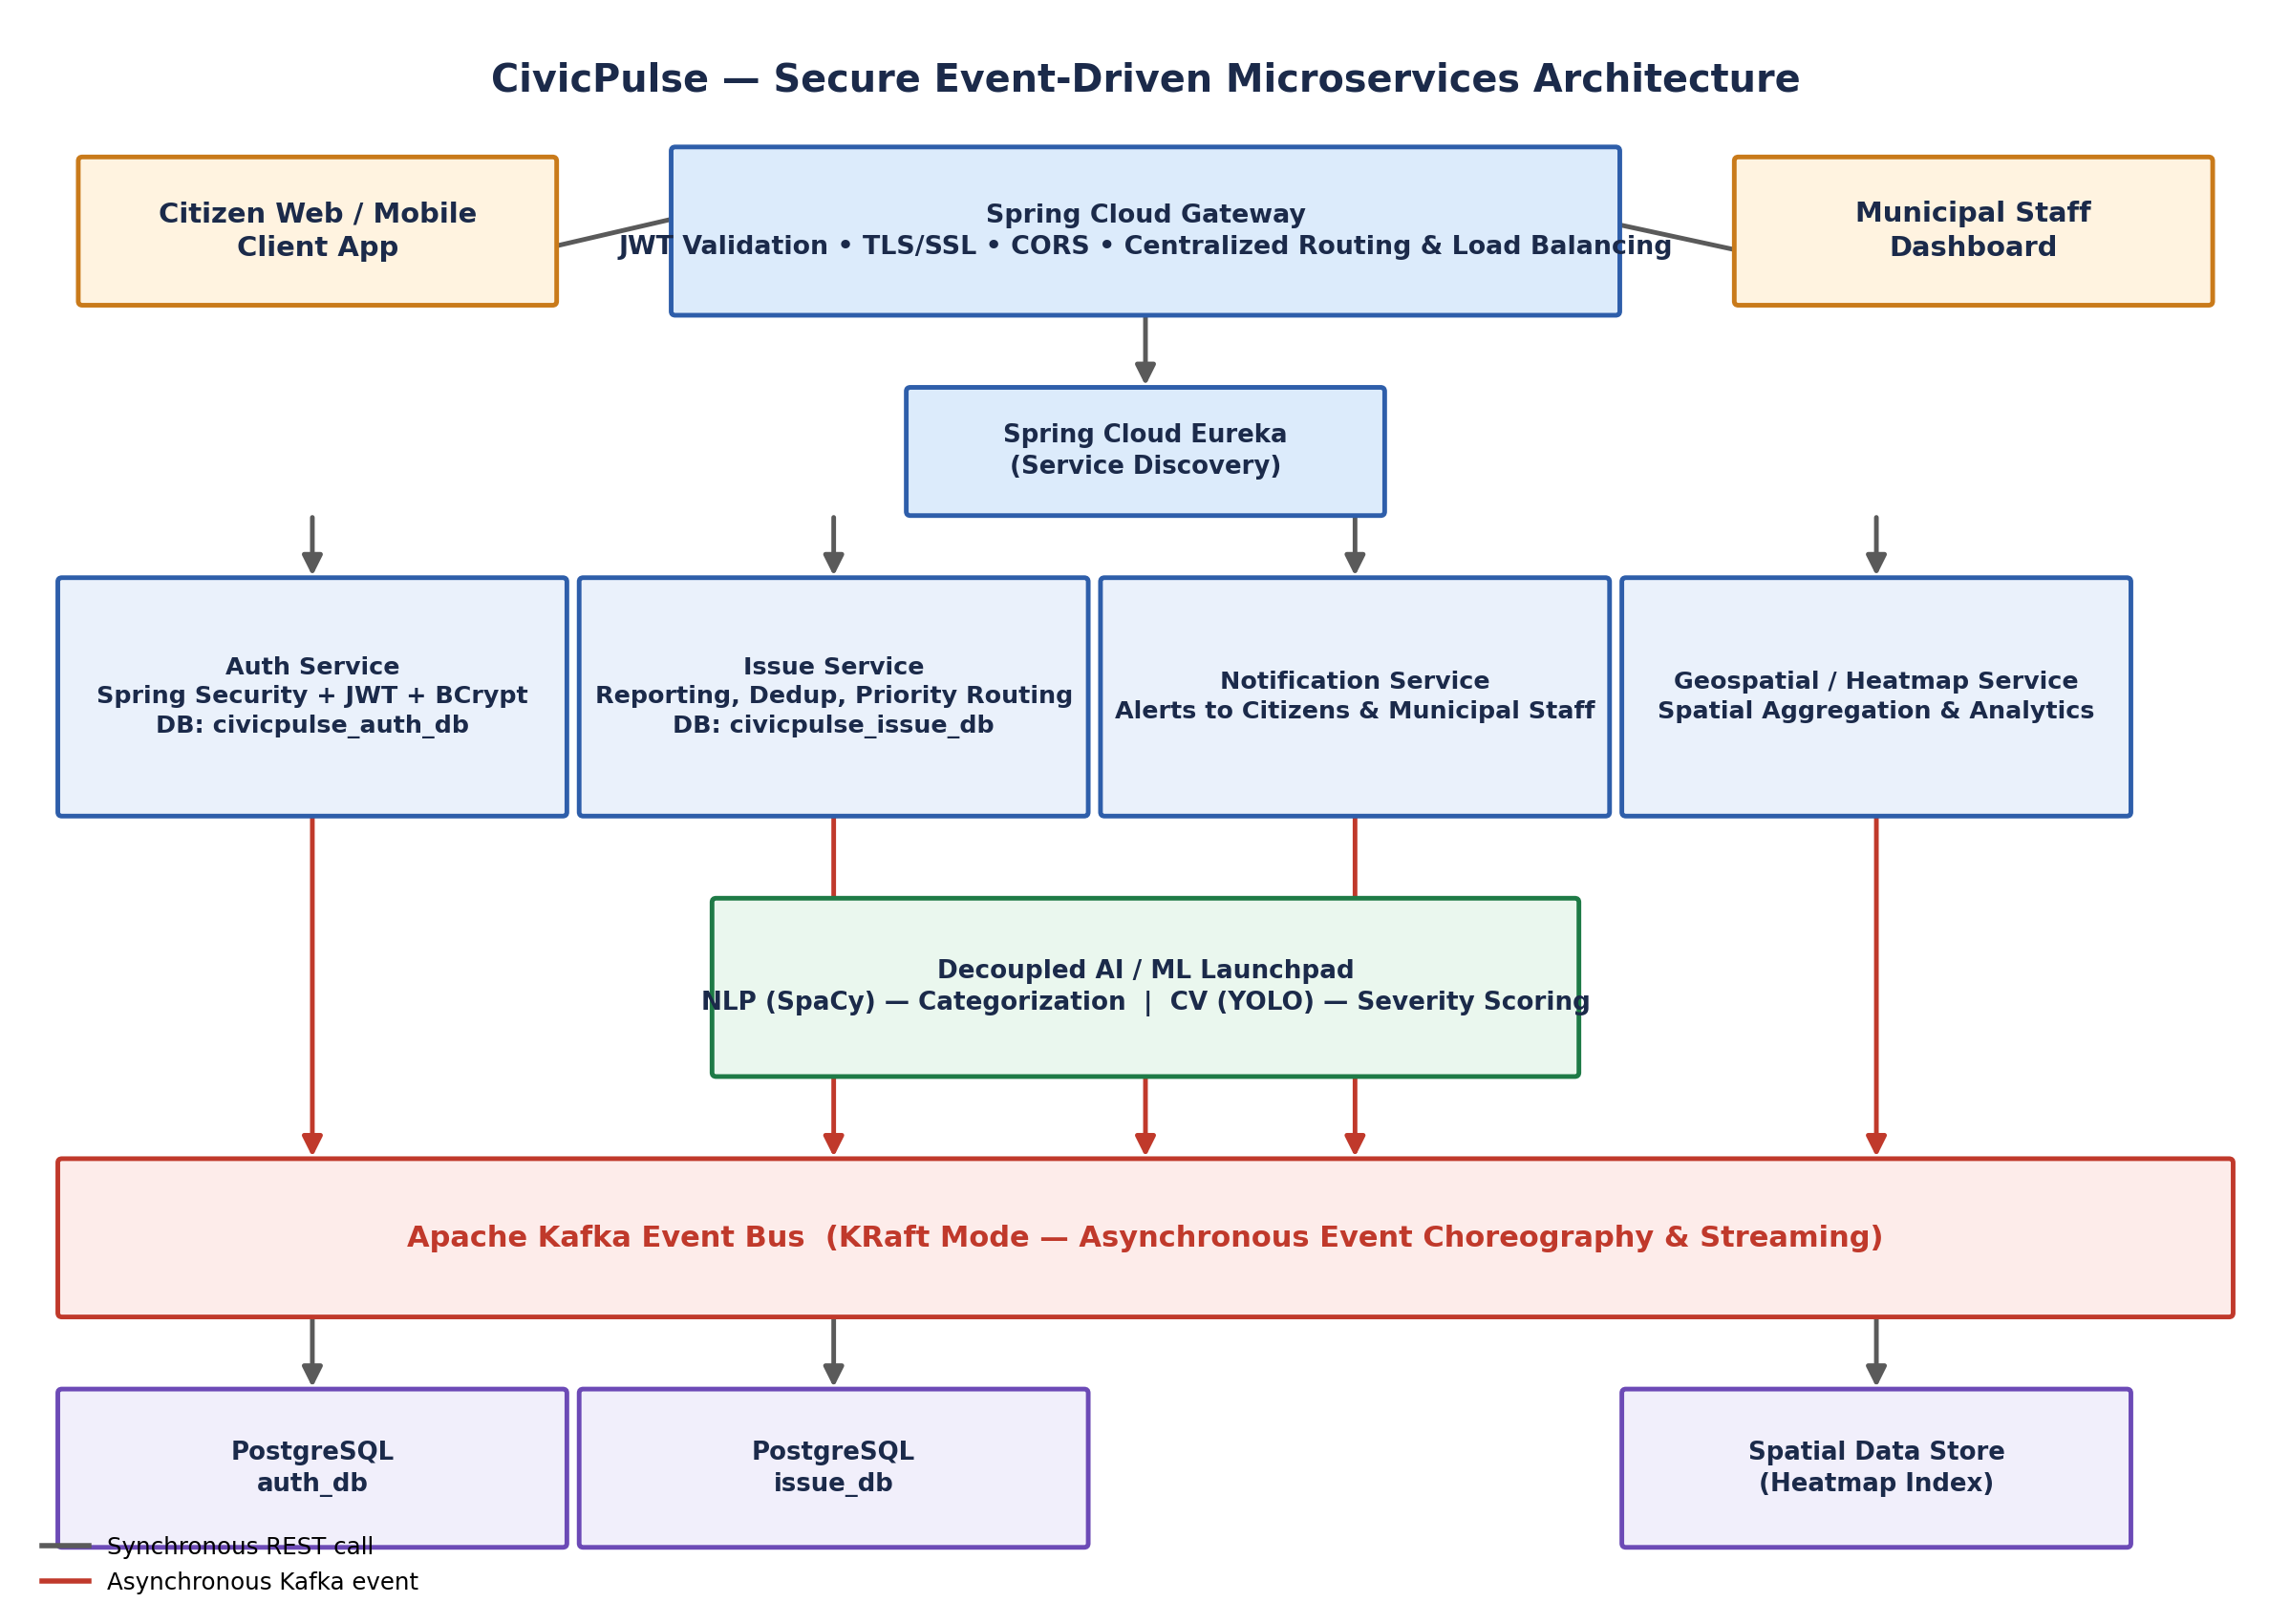
Figure 1. CivicPulse Secure Event-Driven Microservices Architecture

5.1 Event-Driven Issue Reporting Flow
Figure 2 illustrates the runtime flow of a single citizen-reported issue through the system. A citizen submits an issue through the JWT-authenticated gateway; the Issue Service persists the record and immediately returns a synchronous acknowledgment, ensuring a zero-downtime, responsive user experience. The Issue Service then publishes a domain event to the Kafka event bus. Three downstream consumers process this event asynchronously and in parallel: the AI/ML launchpad performs classification, deduplication, and severity scoring; the Heatmap Service consumes the event to update real-time spatial visualizations for municipal planners; and the Notification Service dispatches status updates to the citizen and the responsible municipal department. Because these consumers operate independently of the original request thread, a slow or temporarily unavailable downstream consumer never blocks the citizen-facing submission flow.
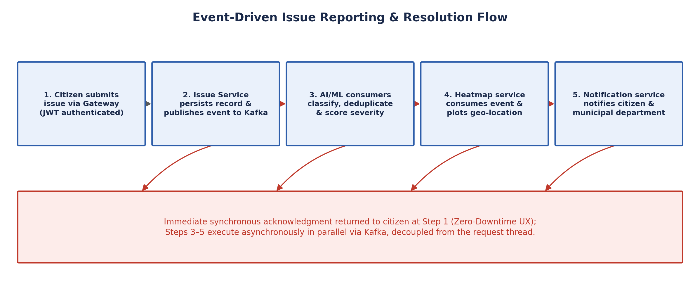
Figure 2. Event-Driven Issue Reporting and Resolution Flow

5.2 Security Architecture
Security is enforced in depth rather than at a single boundary. Spring Cloud Gateway performs the first line of defense with JWT validation and TLS/SSL termination for all inbound traffic. The Auth Service issues and manages JWTs, storing credentials using BCrypt password hashing within its own isolated civicpulse_auth_db. All inter-service traffic that must remain synchronous is likewise routed through TLS-secured channels, while Kafka-based inter-service communication is isolated within the platform's internal network boundary. This layered defense-in-depth strategy guarantees data confidentiality, integrity, and resilience against common vulnerability vectors such as token replay, credential leakage, and man-in-the-middle interception.

5.3 Database-per-Service Pattern
Each core microservice owns a private, independently scalable data store — for example, civicpulse_auth_db for the Auth Service and civicpulse_issue_db for the Issue Service — accessed exclusively through Spring Data JPA repositories owned by that service. No service reaches directly into another service's schema. This removes the shared-database anti-pattern that causes lock contention and cascading failures in monolithic civic platforms, and allows each service's storage technology and scaling strategy to evolve independently of the others.

6. Development Methodology, Testing and CI/CD Pipeline
The development of CivicPulse follows Agile practices throughout its lifecycle. Jira is used for user-story mapping, sprint planning, daily stand-ups, security task tracking, test-case reviews, and sprint retrospectives, ensuring continuous alignment between engineering output and evolving municipal requirements.
System reliability is sustained through a multi-tier automated testing strategy: unit tests validate isolated business logic, integration tests (using @SpringBootTest) verify interactions between Spring components and the Kafka event bus, and contract/data-layer tests (using @DataJpaTest and AssertJ) validate persistence behavior for each service's isolated database. Deployment workflows are fully automated through CI/CD pipelines managed via GitHub Actions, which run the full test suite on every commit and promote validated builds toward production. Figure 3 depicts the closed-loop Agile, testing, and CI/CD workflow, including the feedback loop from security task tracking and sprint retrospectives back into active development.
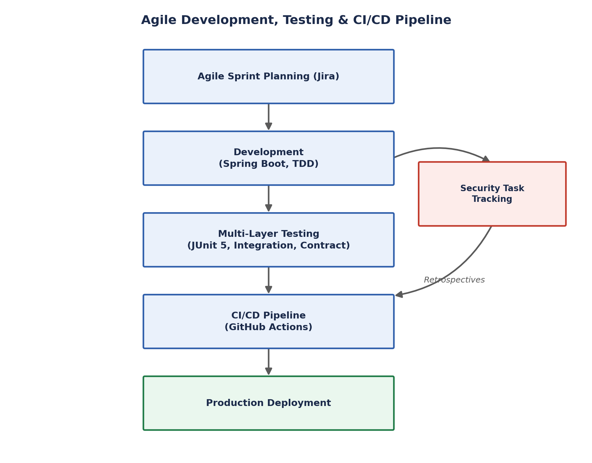
Figure 3. Agile Development, Testing and CI/CD Pipeline

7. Innovation, Creativity and Novelty

7.1 Innovation and Creativity
- Decoupled Civic Mesh: replaces fragile monolithic municipal portals with an event-driven microservices core, guaranteeing uninterrupted application responsiveness and zero-downtime performance during high-traffic emergency surges.
- Isolated Architecture: combines dynamic Eureka routing with strict database-per-service isolation across domains, eliminating single points of failure and preventing shared-database bottlenecks across municipal departments.
- Continuous Resiliency: automates contract validation through continuous GitHub Actions CI/CD deployment pipelines, ensuring production-grade software quality and seamless, continuous service delivery without manual intervention.

7.2 Novelty Comparison
Table 2 contrasts the CivicPulse architecture against baseline civic-portal designs currently prevalent in municipal deployments, highlighting the technical novelty and measurable operational impact of each architectural decision.
Table 2. Novelty Comparison — Baseline Models vs. CivicPulse Architecture
Feature Dimension | Baseline / Existing Models | CivicPulse Architecture | Technical Novelty & Impact
Communication Flow | Synchronous REST APIs — requests execute synchronously; portal stalls during traffic spikes. | Asynchronous Kafka EDA — event messaging via Apache Kafka operating in KRaft mode. | Zero downtime: delivers immediate submission acknowledgments while backend tasks run asynchronously.
AI / ML Execution | Inline processing — ML algorithms (TF-IDF, CNNs) run inline, locking web-app threads. | Decoupled AI launchpad — Kafka payloads stream to Python NLP (SpaCy) and CV (YOLO) services. | Latency-free intelligence: automates issue categorization and visual severity scoring without blocking UI traffic.
Data Isolation | Centralized database — shared databases create lock contention and single points of failure. | Database-per-service — isolated PostgreSQL instances (civicpulse_auth_db, civicpulse_issue_db). | Domain autonomy: prevents cross-service failures and database locks across municipal departments.
Geospatial Analytics | Direct database queries — runs heavy analytical SQL queries against primary tables. | Passive stream workers — heatmap microservices passively monitor Kafka event streams. | Zero operational load: plots real-time spatial heatmaps with zero query burden on transactional data.
Edge Security & CI/CD | Minimal edge protection — unencrypted inter-service calls and manual deployments. | Layered security & CI/CD — Spring Cloud Gateway, JWT, BCrypt, TLS, and GitHub Actions CI/CD. | Production resiliency: guarantees defense-in-depth protection and automated contract validation.

8. Feasibility Analysis and Project Plan

8.1 Feasibility Analysis
- Technical Feasibility: leverages a proven, open-source stack (Spring Boot, Kafka, Eureka) with low implementation risk.
- Operational Feasibility: simplifies civic workflows via automated incident routing and requires minimal manual staff training.
- Economic Feasibility: reduces long-term infrastructure costs by relying on open-source tooling and cloud auto-scaling rather than proprietary licenses.

8.2 Project Plan
- Phase 1 — Setup & Specification: requirements gathering, API design, Jira board setup, and core microservice scaffolding.
- Phase 2 — Core Build: Spring Cloud Gateway integration, Kafka event-streaming setup, and database-per-service isolated deployment.
- Phase 3 — Security & AI Integration: JWT edge-security implementation, TLS integration, and ML deduplication/categorization service inclusion.
- Phase 4 — Testing & CI/CD: JUnit 5 integration testing, GitHub Actions automated CI/CD pipeline setup, and performance benchmarking.

9. Expected Results and Discussion
Based on the architectural decisions detailed in Sections 5 through 7, CivicPulse is expected to demonstrate marked qualitative improvements over monolithic and synchronous-REST baseline systems along four dimensions. First, responsiveness: because issue submission is decoupled from downstream AI classification, notification, and geospatial processing via Kafka, citizen-facing acknowledgment latency is expected to remain stable even under bursty reporting load, in contrast to baseline systems that stall under synchronous processing. Second, fault isolation: the database-per-service pattern and independent service boundaries are expected to confine the impact of a service-level fault (for example, an AI/ML service outage) to that service alone, without degrading issue submission or authentication.
Third, security posture: the combination of gateway-level JWT validation, BCrypt credential hashing, and TLS/SSL encryption across all channels is expected to close the edge-security gaps identified in the research-gap analysis (Section 3.1), providing defense-in-depth relative to baseline platforms that rely on minimal or unencrypted inter-service communication. Fourth, delivery velocity and quality: the multi-tier automated test suite combined with GitHub Actions CI/CD is expected to shorten feedback cycles and reduce the incidence of regressions reaching production, relative to manually deployed civic portals. Formal load-testing, security-penetration testing, and production telemetry are identified as immediate next steps to empirically validate these expected outcomes.

10. Conclusion and Future Work
CivicPulse demonstrates that a secure, event-driven microservices architecture — combining Apache Kafka event choreography, Spring Cloud Gateway/Eureka routing and discovery, JWT-based layered security, and a database-per-service persistence model — can directly address the scalability, security, and intelligence gaps present in traditional monolithic civic issue management platforms. By decoupling issue submission from downstream classification, notification, and geospatial analytics, the platform is designed to remain responsive and resilient during high-traffic emergency surges while giving municipal departments real-time, AI-assisted visibility into urban issues.
Future work will focus on extending the current design along the directions identified in the literature survey and research-gap analysis: introducing dynamic auto-scaling and automated failover recovery for the Kafka-driven pipeline, evaluating edge-computing strategies to handle intermittent connectivity for IoT-integrated civic sensors, and enriching the AI/ML launchpad with distributed tracing and OAuth2-based edge authentication for even stronger cross-service security guarantees. Empirical performance benchmarking and a pilot municipal deployment are planned as the next validation milestones.

11. References
- Gbenle, T. P. et al., "A Conceptual Model for Scalable and Fault-Tolerant Cloud-Native Architectures for Emergency Response Systems," referenced in CivicPulse literature survey.
- AirQo Team (Sserujongi, E. et al.), "Design and Evaluation of a Scalable Data Pipeline for AI-Driven Air Quality Monitoring," referenced in CivicPulse literature survey.
- Grenze Research Group, "Smart Civic Issue Reporting System," referenced in CivicPulse literature survey.
- Spring Cloud Gateway Reference Documentation, VMware Tanzu / Spring.io.
- Spring Cloud Netflix Eureka Reference Documentation, Spring.io.
- Apache Kafka Documentation — KRaft Mode, Apache Software Foundation.
- Spring Security Reference Documentation — JSON Web Token (JWT) Authentication, Spring.io.
- GitHub Actions Documentation — Continuous Integration and Continuous Deployment, GitHub, Inc.

12. Acknowledgment
The authors sincerely thank Dr. Srikanth Cherukuvada, Assistant Professor, Department of Computer Science and Engineering, KLH — Bowrampet Campus, for his continuous guidance, technical review, and mentorship throughout the design and development of the CivicPulse platform under the SOA Programming and Microservices (24SDCS03) course.

